**(02)**

Digital Distance Meter

Software Requirements Specification

18/3/2016

Eng.Mohammed Hassan

Lead Software Engineer

Prepared By

**Nuha Baha’a**

**Ahmed Fanni**

# **Revision History**

|  |  |  |  |
| --- | --- | --- | --- |
| **Date** | **Description** | **Author** | **Comments** |
| Date | Version Number | Your Name | First Revision |
| 18/3/2016 | #1 | Nuha Bahaa |  |
| 8/4/2016 | #2 | Nuha Bahaa | Tags Edited |
|  |  |  |  |

**Table of Contents**

Revision History

1. Introduction

1.1 Purpose

1.2 Scope

1.3 Definitions, Acronyms, and Abbreviations

1.5 Overview

2. General Description

2.1 Product Perspective

2.2 Product Functions

2.3 User Characteristics

2.4 General Constraints

2.5 Assumptions and Dependencies

3. Specific Requirements

3.1 External Interface Requirements

3.1.1 User Interfaces

3.1.2 Hardware Interfaces

3.2 Functional Requirements

3.2.1 <Display Distance>

[07_API6_S1,7_C4_T8_CR  
04_API3_S7_C4_T9,10_CR](#h.rfjs2maekmdt)

3.2.2 <ReadDistance>

(04_API3_S7_C4_T9,10_CR)

3.2.2.1 Introduction

3.2.4 <Buzzer Running>

(03_API1_S4_C10_T_CR)

3.2.4.1 Introduction

3.3 Use Cases

3.3.1 Digital Distance Meter System

3.4 Non-Functional Requirements

3.4.1 Performance

3.4.3 Maintainability

3.4.4Portability

3.5 Design Constraints

5. Change Management Process

# 

# 

# 

# 

# 

# **1. Introduction**

## **1.1 Purpose**

*This SRS is written for technical engineer in order to be aware of customer requirements*

*and it is also written for all the project team members to make the product targets clear.*

## **1.2 Scope**

Digital Distance Meter is a device used to measure distance accurately and efficiently, the device's range limit is 3m max and 10cm min.

*The Project will introduce new digital distance meter; including the following:*

- *Ultrasonic sensor HC-SR04*

- *Alphanumeric LCD 2x16*

- *Atmega32 micro-controller*

- *Buzzer*

*The project target is to measure distance accurately and when reaching certain threshold distance a buzzer gets turned on.*

*The project only measure distance and take action based on it, no more features are included.*

## **1.3 Definitions, Acronyms, and Abbreviations**

LCD: Liquid Crystal Display

## **1.5 Overview**

* *The 1st section describes the product definition, purpose and scope.*
* *The 2nd section describes the product description, perspective, functionality, characteristic and constraints.*
* *The 3rd section describes the product requirement (functional and non functional) and the system functions using case diagram.*

# **2. General Description**

## **2.1 Product Perspective**

*This Product is one time stand alone product, no further development will be introduced in this product.*

*This product is composed of 4 main components:*

* *LCD module*
* *Ultrasonic sensor module*
* *Atmega32 micro-controller*
* *Buzzer*

## **2.2 Product Functions**

* Through Ultrasonic sensor’s reading and after some math calculations using Atmega32 micro-controller distance will be calculated between the user and the obstacle and print the distance on LCD.
* When the measured distance reaches a certain threshold point a buzzer goes on.

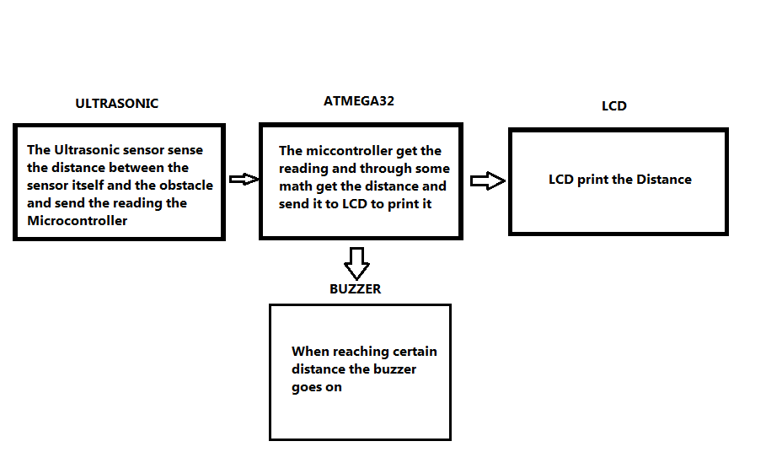

## **2.3 User Characteristics**

This product is not dedicated for certain or specific user it’s for general public any gender with any age can use it but the user age must be at least 15 years old and above.

## **2.4 General Constraints**

*Due to using micro-controller with limited memory we can’t save the past distance measurements which leads to less functionality and limit any further development in the product*

## **2.5 Assumptions and Dependencies**

* The hardware components are available and no shortage of any of the component’s stock

# **3. Specific Requirements**

## **3.1 External Interface Requirements**

|  |  |
| --- | --- |
| **Requirement** | **Tag** |
| Supports unit selection of meter | 07_API6_S1_C4_T8_CR |
| Handheld Digital Distance | X_X_S2_C3_X_CR |
| No Log system or memory Required | X_X_S3_C9_X_CR |
| Voice indication | (03_API1_S4_C10_T_CR)  (03_API1_S4_C10_T_CR) |
| Battery Power Based | X_X_S5_C6_T_CR |

### **3.1.1 User Interfaces**

|  |  |
| --- | --- |
| **Requirement** | **Tag** |
| -16 character *2 Lines LCD with colored back-light | X_X_S6_C7_X_CR |

### **3.1.2 Hardware Interfaces**

|  |  |
| --- | --- |
| **Requirement** | **Tag** |
| -Ultrasonic sensor measure the distance | 04_API3_S7_C4,8_T9,10_CR |

## **3.2 Functional Requirements**

### **3.2.**1 **<**Display Distance**>**

### 07_API6_S1,7_C4_T8_CR 04_API3_S7_C4_T9,10_CR

### 

3.2.1.1 Introduction

Display distance in digital format in meters

3.2.1.2 Inputs

reads from the ultrasonic sensor

3.2.1.3 Processing

send signal by the ultrasonic sensor to the target point and calculate the distance according to the reflected signal.

3.2.1.4 Outputs

Distance in digital representation on led represents in digital english numbers on LCD.

### 3.2.2 <ReadDistance>

### (04_API3_S7_C4_T9,10_CR)

### 

### 3.2.2.1 Introduction

System should be able to detect the distance using ultrasonic sensor.

3.2.4.2 Inputs

Reading input signal from the ultrasonic sensor.

3.2.2.3 Processing

ultrasonic will measure the value by calculating the difference between the transmitted and received signal.

3.2.2.4 Outputs

Distance will be measured and displayed on the LCD.

3.2.2.5 Error Handling

put the ultrasonic in stable place.

### 3.2.4 <Buzzer Running>

### (03_API1_S4_C10_T_CR)

### 

### 3.2.4.1 Introduction

System should run the buzzer whenever the distance exceed the limits.

3.2.4.2 Inputs

none

3.2.4.3 Processing

ultrasonic cant detect more than its distance limit ,micro-controller will send signal to run the buzzer.

3.2.4.4 Outputs

Buzzer turning on.

3.2.4.5 Error Handling

Test the system when the ultrasonic fails to measure distance more than its limits.

## **3.3 Use Cases**

### **3.3.1** Digital Distance Meter System

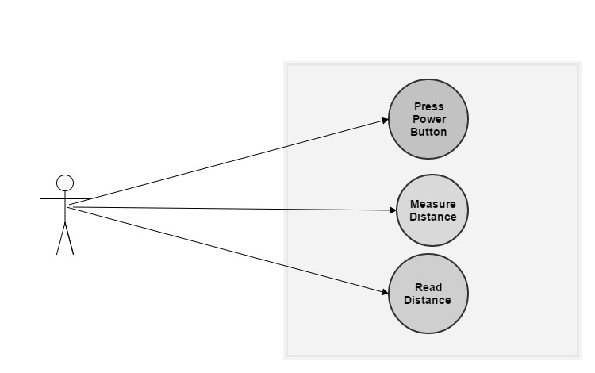

## **3.**4 **Non-Functional Requirements**

### **3.**4**.1 Performance**

Tag:X_X_S8_X_T11_DR

### System should be able to work with 100% performance and regular power consumption in normal room temperature and Humidity.

**3.4.2 Reliability**

Tag:X_X_S9_X_T12_DR

System responding to user action should be in less than 1second.

Tag:(04_API3_S7_C4_T9,10,13_CR)

Distance should be accurate error parentage shouldn’t exceed 2%.

### **3.**4**.**3 **Maintainability**

Tag:X_X_S10_X_T14_DR

Device is surrounded by shield to protect the inner components from destroying

### **3.**4**.**4**Portability**

Tag:X_X_S10_C2_T14_DR

Handheld device with acceptable size and holder.

## **3.**5 **Design Constraints**

-Ultrasonic sensor maximum range is 3m ,so if distance is larger than 3m device will not be able to measure the distance.and should be able to sense till 10cm.

# **5. Change Management Process**

|  |  |  |  |  |
| --- | --- | --- | --- | --- |
| *Name* | *Update Number* | *Update Description* | *Update Date* | *Approving Check* |
| *Nuha Bahaa* | *1* | *Table for requirements codes* | *31/3/2016* |  |

## 